Restaurant management system

Project report

**TEAM MEMBERS :**

|  |  |
| --- | --- |
| NAME | ROLL NO |
| NAVAMI S | AM.EN.U4CSE21239 |
| FELIX JOHN | AM.EN.U4CSE21277 |
| KANDIKUNTA GAYITHRI | AM.EN.U4CSE21230 |
| AKSHAY M NAIR | AM.EN.U4CSE21207 |
| BONTHU YASASWINI | AM.EM.U4CSE21217 |
| SHILPA DEEPAK | AM.EN.U4CSE21252 |

### **Project Scope**

### The **Restaurant Management Application** is a robust software solution aimed at simplifying and automating restaurant operations. It allows restaurant staff to manage menus, accept orders, handle table reservations, and process bills effectively. For customers, the application offers a seamless interface to browse the menu, place orders, and reserve tables conveniently.

**Objectives:**

1. Offer customers an easy-to-use platform for reservations, orders, and table preferences.
2. Equip restaurant staff with tools to efficiently manage reservations, orders, and table statuses.
3. Provide a scalable and secure architecture to ensure reliable performance and data management.
4. Automate communication and notifications to improve customer satisfaction and operational transparency.

### **Team Roles and Responsibilities**

|  |  |  |
| --- | --- | --- |
| Name | Roll Number | Role |
| Navami S | AM.EN.U4CSE21239 | Frontend Development, Team Lead |
| Felix John | AM.EN.U4CSE21277 | Backend Development, Database Design |
| Shilpa Deepak | AM.EN.U4CSE21252 | Quality Analysis |
| Yasaswini Bonthu | AM.EN.U4CSE21217 | Documentation |
| Gayithri K | AM.EN.U4CSE21230 | UI/UX Designer |
| Akshay | AM.EN.U4CSE21207 | Support Developer |

### **1. Reservation Management:**

* A system for customers to book tables with specific requirements such as date, time, and the number of guests.
* Real-time updates on table availability to prevent overbooking.

### **2. Automated Communication:**

* Sending automated emails and SMS notifications for:
  + Reservation confirmations.
  + Reminder notifications for upcoming reservations.
  + Updates or cancellations of bookings.

### **3. Table Status Management:**

* Tools for staff to monitor and update table statuses in real time (e.g., available, reserved, occupied, or under maintenance).
* Visual dashboard for managing restaurant floor plans effectively.

### **4. Order Management:**

* A digital menu system for customers to place orders directly.
* Integration of order tracking for the kitchen staff to streamline food preparation.
* Options for dine-in, takeaway, or home delivery orders.

### **5. User Management:**

* Secure user registration and login functionalities for customers and staff.
* Role-based access control (Admin, Manager, Waitstaff, Chef, Customer).

### **6. Technological Integration:**

* **Backend:** Powered by robust technologies like Spring Boot for secure and scalable operations.
* **Frontend:** Designed with Angular for a dynamic and user-friendly interface.
* **Database:** MySQL integration for reliable data persistence and operations.

### **7. Developer Tools:**

* Easy-to-follow setup and development using Maven, Node.js, and Angular CLI.
* Swagger for API documentation and testing.

### **Key Features**

1. **User Registration & Login:**
   1. Secure account creation and login functionality.
   2. JWT-based authentication for enhanced security.
2. **Table Reservations:**
   1. A responsive interface for customers to reserve tables.
   2. Dynamic reservation conditions such as preferred seating area, special occasion requests, etc.
3. **Digital Menu:**
   1. Interactive menu display for customers to browse dishes, view ingredients, and place orders.
   2. Options for modifying orders or adding special instructions.
4. **Order Notifications:**
   1. Real-time notifications for the kitchen and waitstaff when new orders are placed.
   2. Updates for customers regarding order preparation and serving times.
5. **Reservation Management:**
   1. Tools for customers and staff to view, edit, or cancel reservations.
   2. Handling special conditions like group reservations or event bookings.
6. **Table Status Management:**
   1. Real-time updates on table statuses (available, reserved, occupied, or under maintenance).
   2. Visual floor plan dashboard for efficient table allocation.
7. **API Integration:**
   1. Swagger-enabled API documentation for testing and future system expansions.
8. **Database Management:**
   1. MySQL as a reliable and scalable database solution.
   2. Hibernate ORM for managing complex database operations.
9. **Frontend Features:**
   1. Intuitive user interface built with Angular and Angular CLI.
   2. Responsive design compatible with desktops, tablets, and smartphones.
10. **Performance & Monitoring:**
    1. Spring Boot Actuator for application health checks and monitoring performance metrics.
11. **Developer Experience:**
    1. Detailed setup and configuration instructions for the development environment.
    2. Integration of MapStruct and Lombok to simplify and speed up development

**High-Level Design**

**System Architecture**

The application follows a **modular design** to ensure scalability and reliability.

1. **Frontend**: Built with Angular for an interactive and responsive UI.
2. **Backend**: Spring Boot with RESTful APIs for secure and efficient server-side operations.
3. **Database**: MySQL with Hibernate ORM for robust and scalable data management.

**Detailed Features with Screenshots and Code Snippets**

**Frontend**

**Technologies Used**:

* Angular, HTML, CSS, JavaScript

**Screenshots**

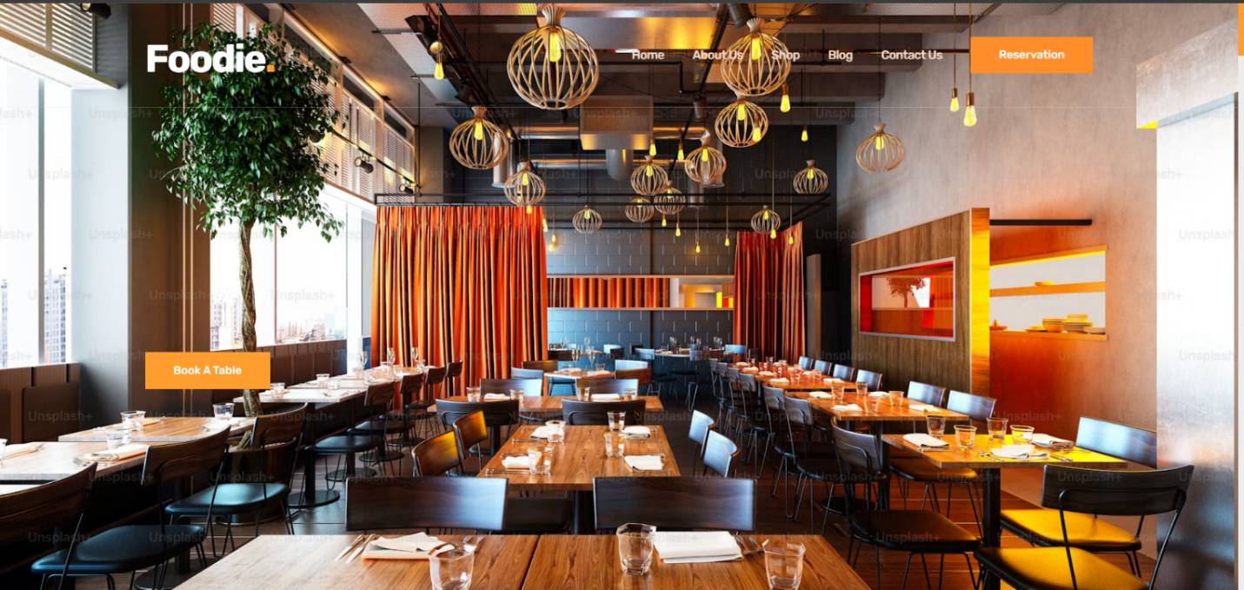

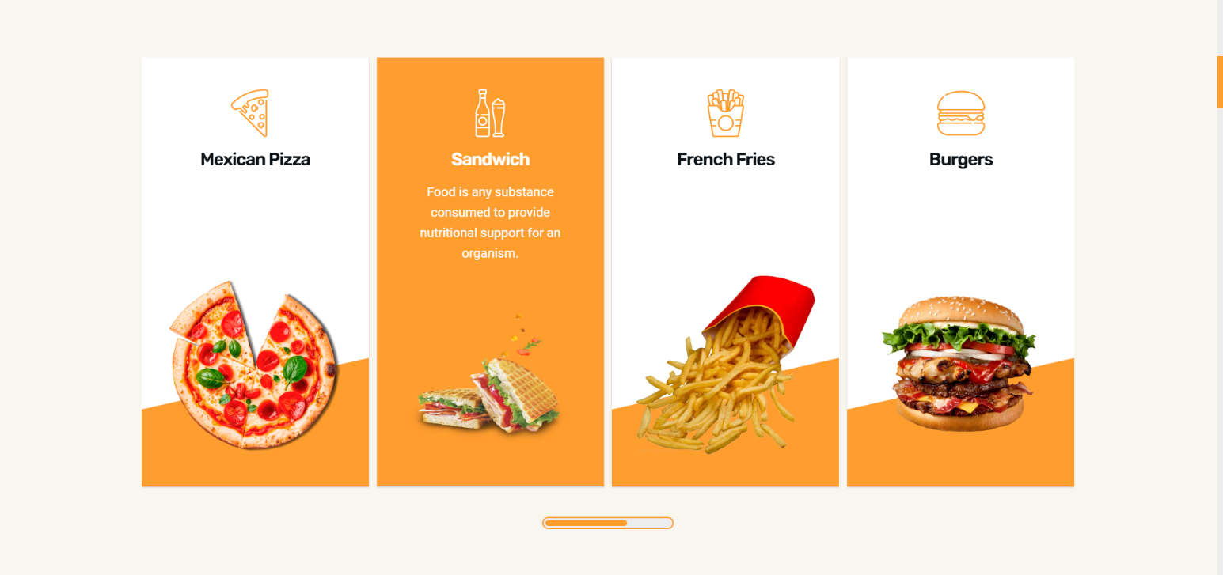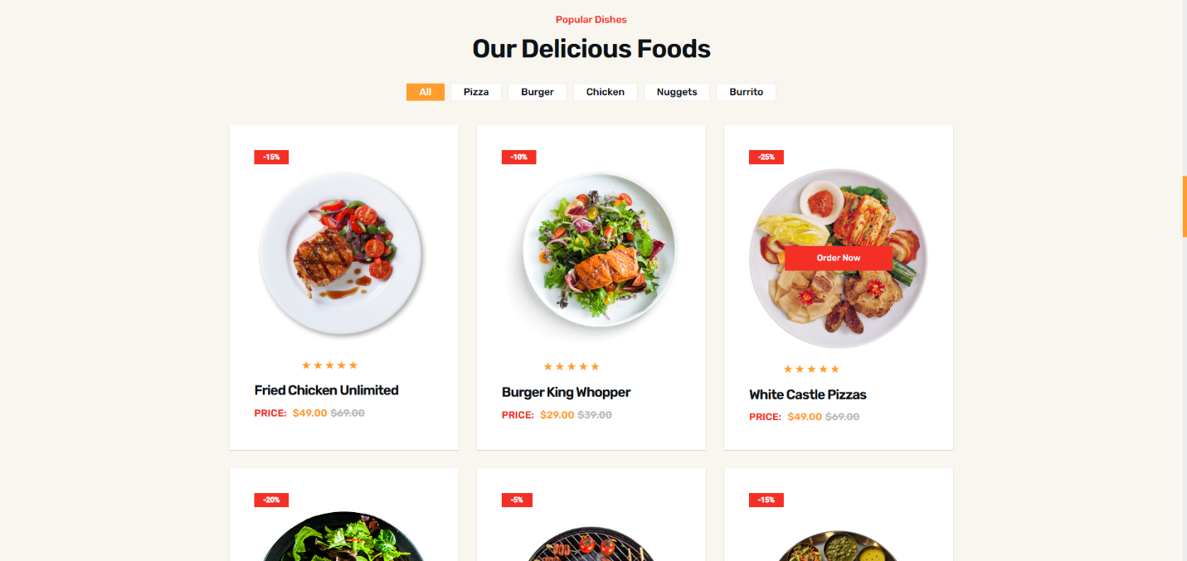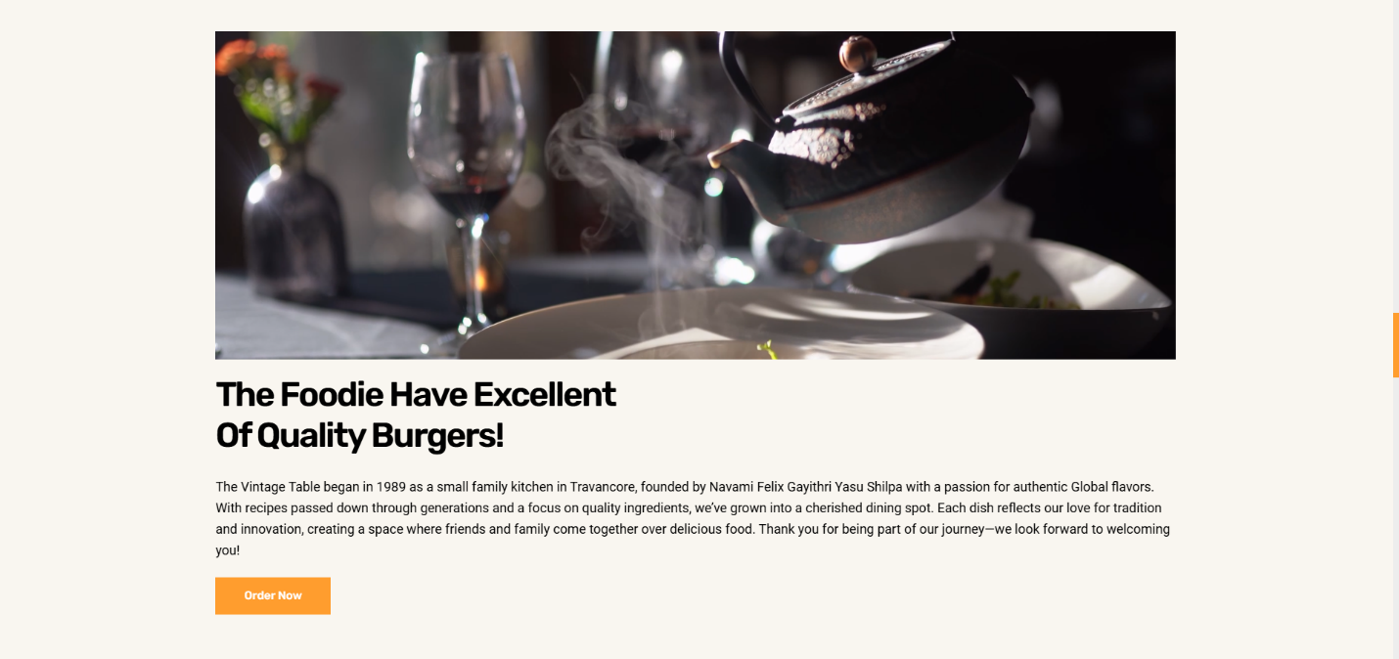

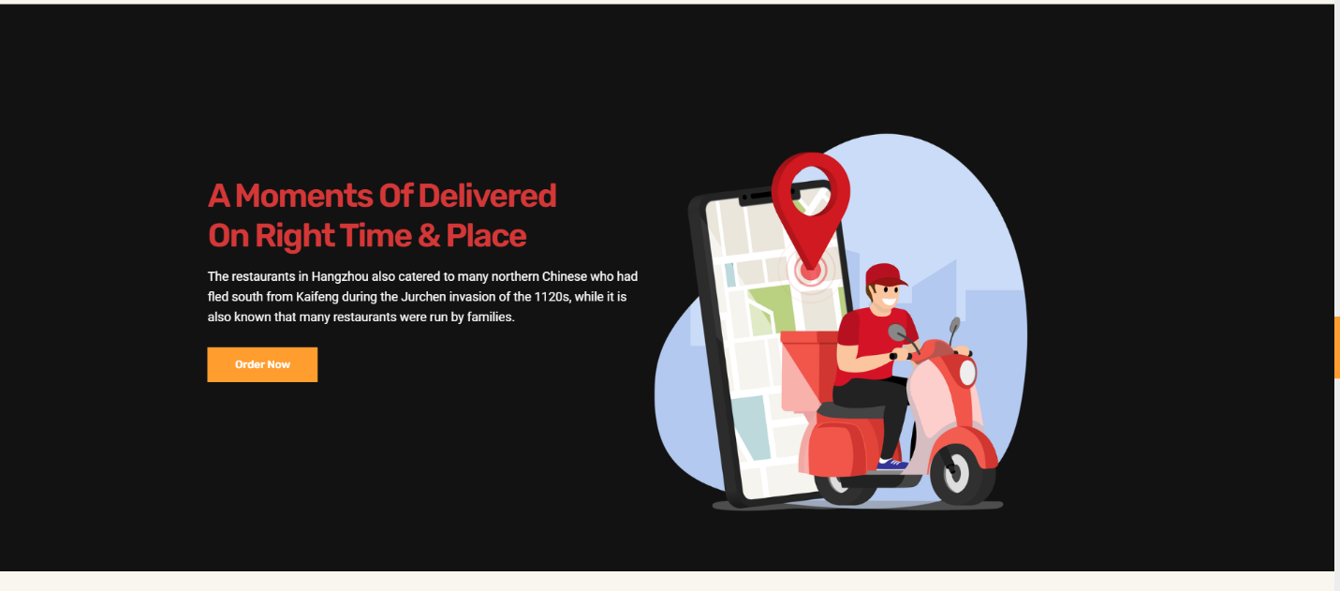

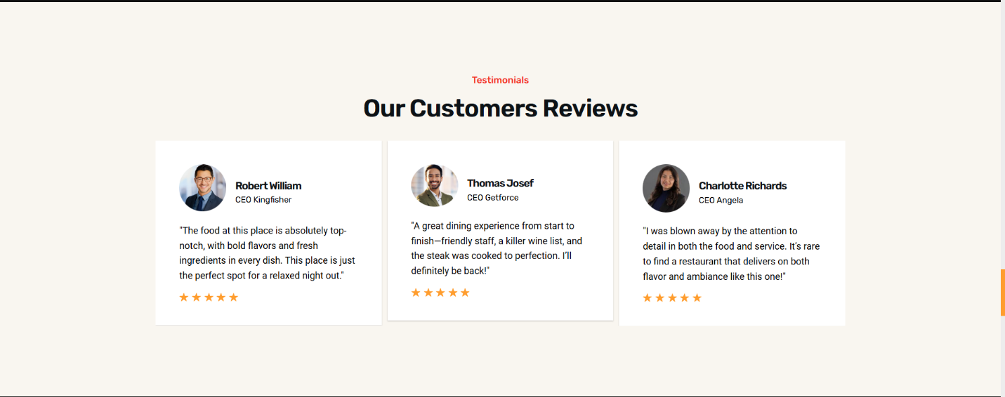

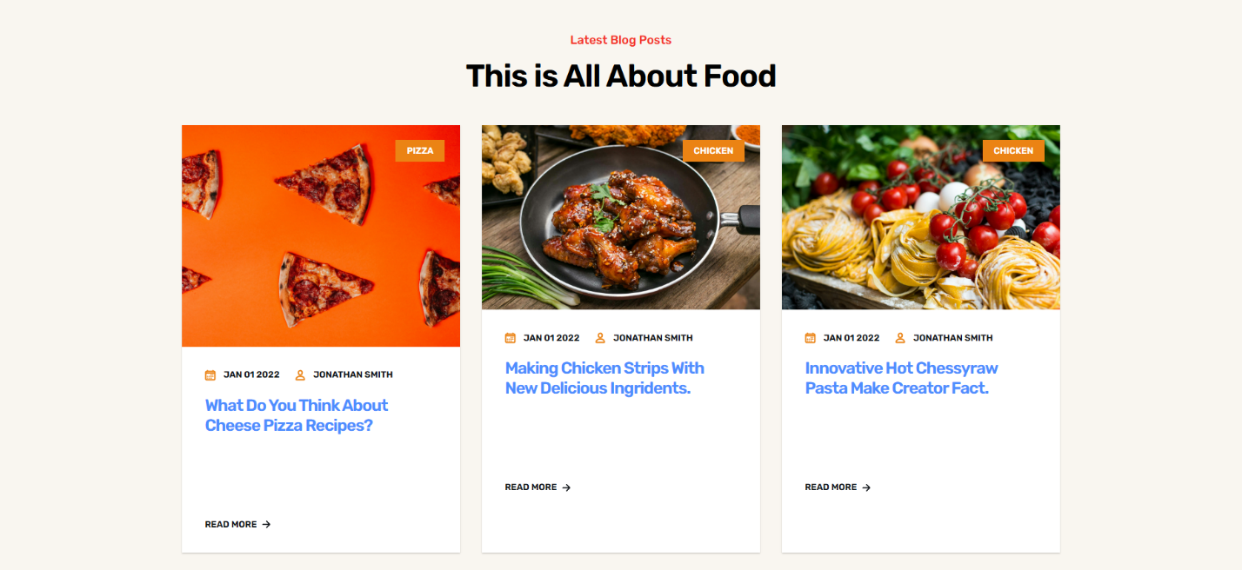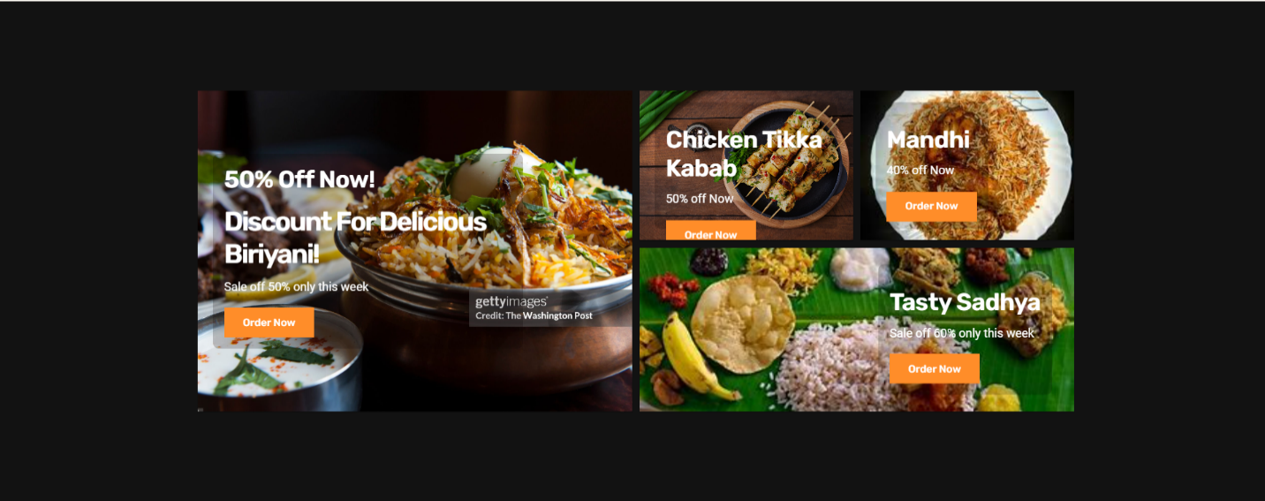

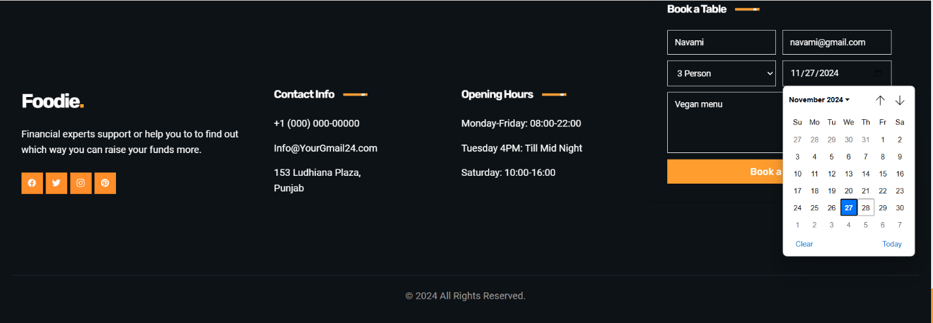

**Snippets of frontend code**

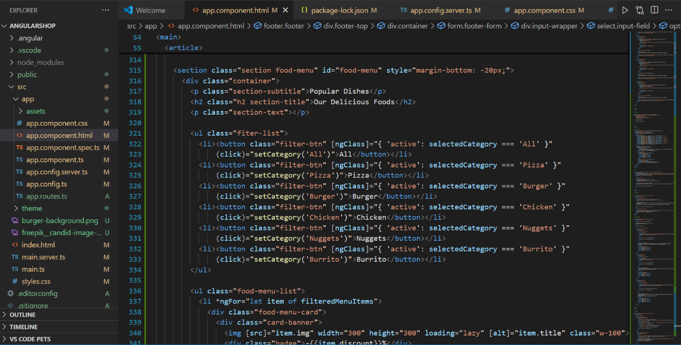

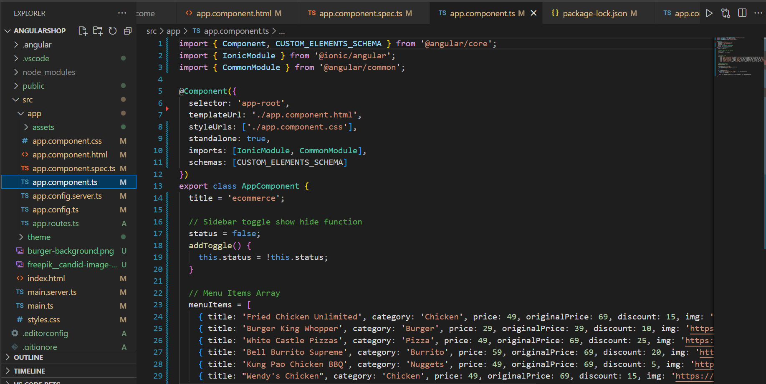

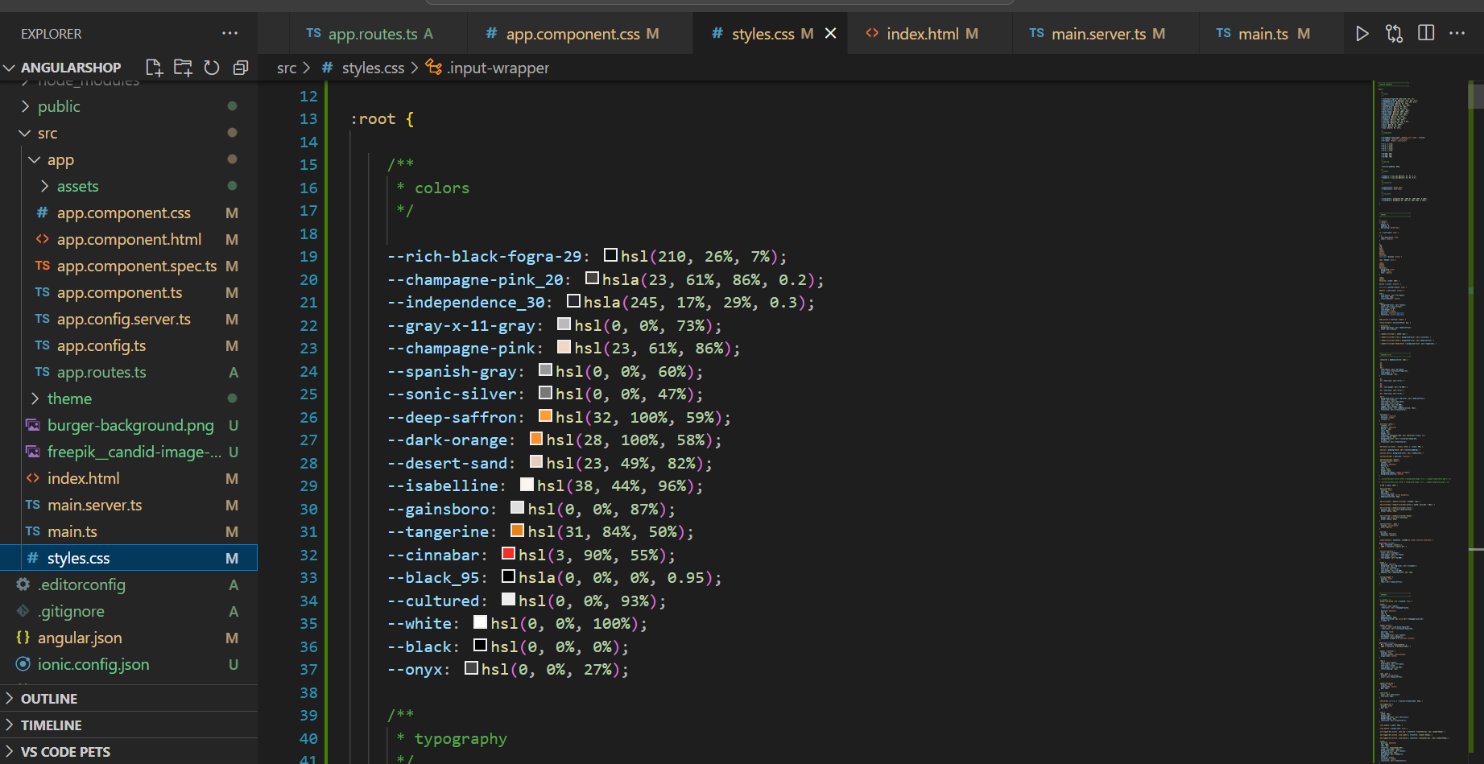

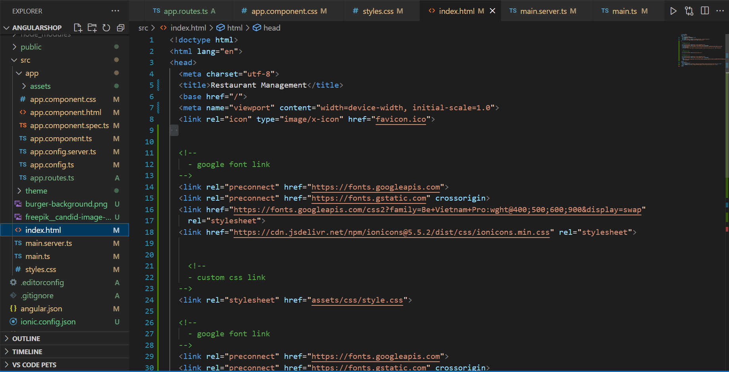

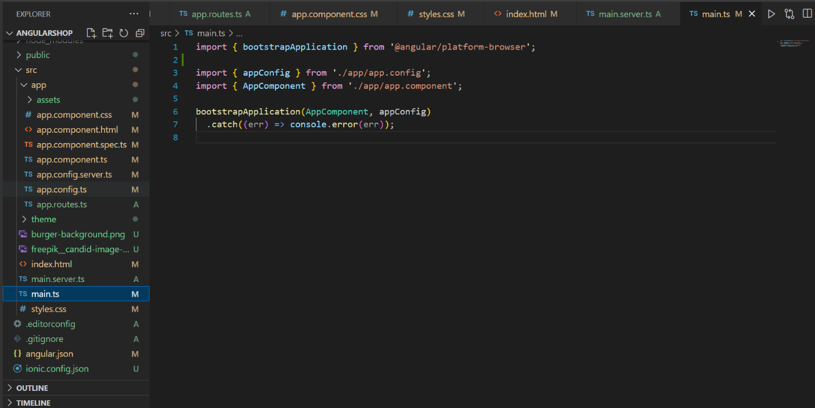

**Backend Implementation**

**Technologies Used:**

* Spring Boot, RESTful APIs, Hibernate ORM

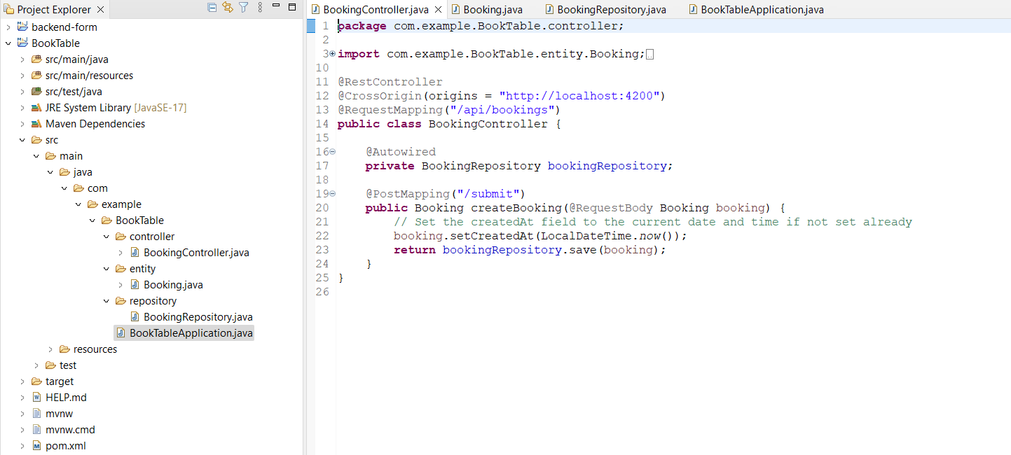

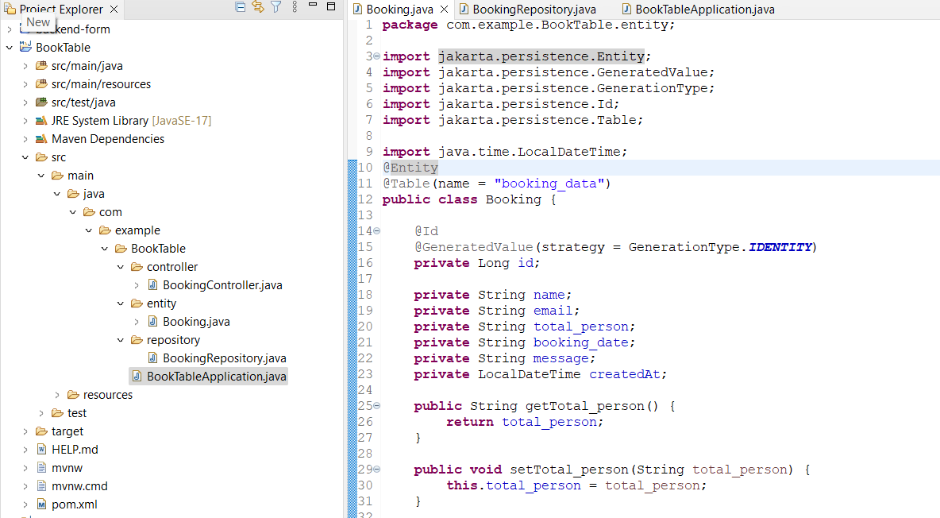

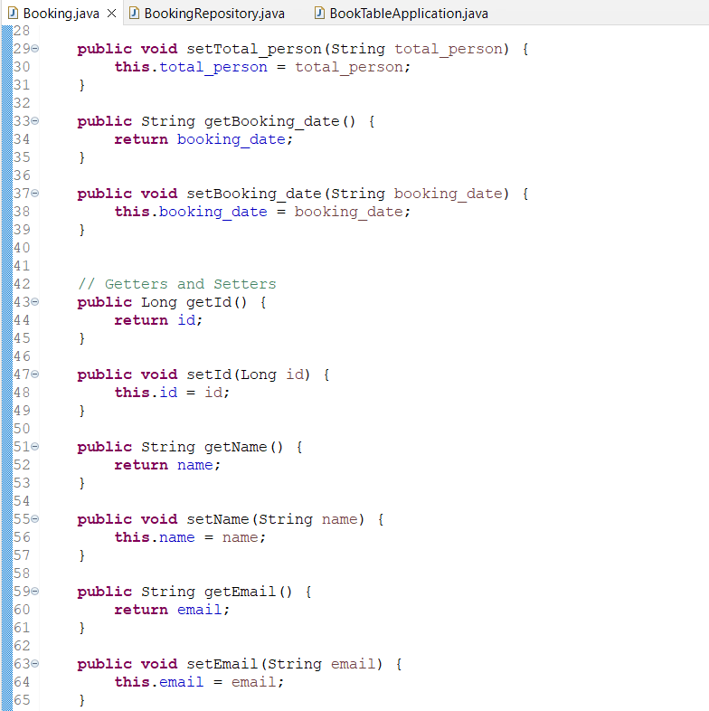

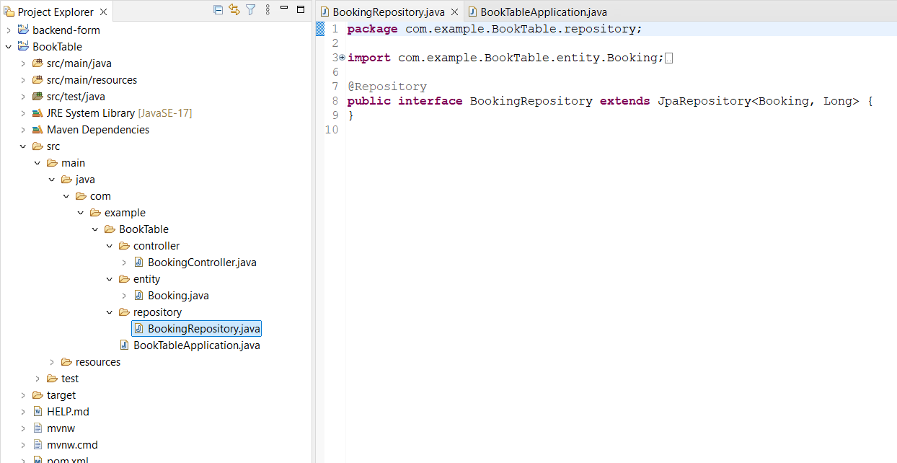

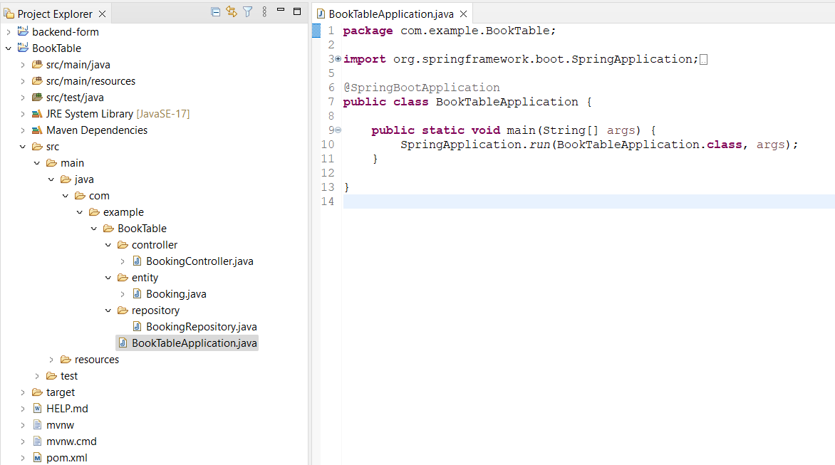

**Database Design**

**Technologies Used:**

* MySQL

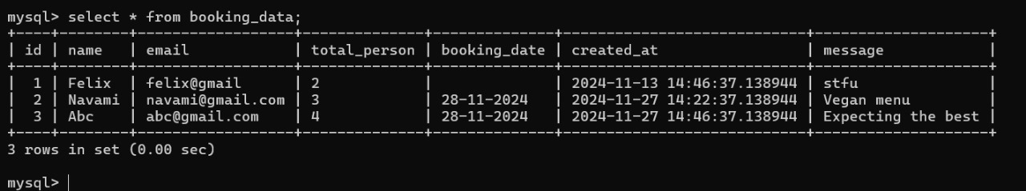

**MySQL Database Tables :**

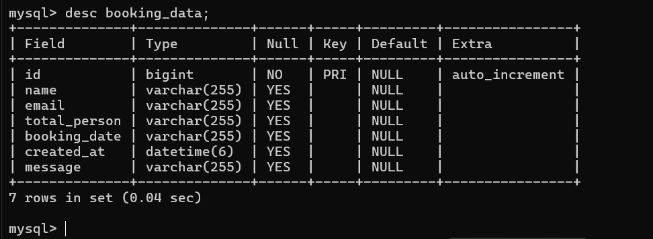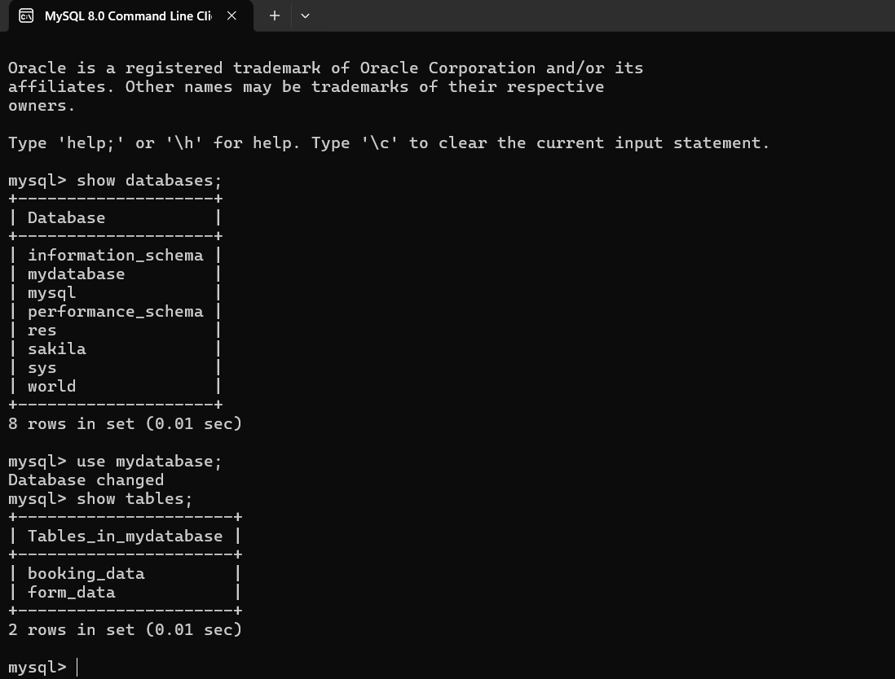

**Conclusion**

The **Restaurant Management System** combines innovative features such as real-time reservations, dynamic order tracking, and automated notifications. It ensures operational efficiency for restaurants and an intuitive experience for users. The modular, scalable architecture supports future enhancements, making it an ideal solution for modern restaurants